Project Report

|  |  |
| --- | --- |
| Product Name | Advanced Certificate in Web Development |
| Qualification Name (NICF) | ITSF - Advanced Certificate in Information Technology (Application Development) |
| Product Name | Front End Web Development |
| Module Name (NICF) | ITSF - Front End Web Development |

|  |  |  |  |
| --- | --- | --- | --- |
| Student name | | Assessor name | |
| Agung Yuda Pratama | |  | |
| Date issued | Completion date | | Submitted on |
|  | 14-10-2022 | | 14-10-2022 |
|  | |  | |
| Project title | Development of website for a Training Organization | | |

|  |
| --- |
| Learner declaration |
| I certify that the work submitted for this assignment is my own and research sources are fully acknowledged.  14-10-2022  Student signature: Date: |

Content

1. Project background
2. Project Objectives
3. Requirement Specifications
4. Task 1
5. Task 2
6. Task 3
7. Task 4
8. Task 5
9. Task 6
10. Task 7

Project Background

I have been approached by ‘ABC Learning Center’ as a website developer to develop a

website for their institute. ‘ABC Learning Center’ is an IT Training institute that conducts

courses like ‘Programming in Java’, ‘Programming in .Net’, ‘Microsoft Office’, ‘HTML’ etc.

They want to design a website which can be used for providing information about their

courses to students and for capturing leads generated by digital marketing.

I will be required to design and develop this website using HTML, JavaScript, CSS,

jQuery & Ajax..

The website that I have developed needs to be tested by me and final sign-off should be

taken from ‘ABC Learning Center’ (Assessor) before hosting it on their web server. I will

also provide supporting technical and user documentation for this website.

Project Objective

To implement the ABC Training Center website Create a storyboard, information architecture, wireframes, and branding. Create a website using Javascript, CSS, and HTML. Create jQuery Tabs & Menus. Using HTML to create a form, JavaScript to validate the form, and Ajax to submit the form. Implement the test cases and confirm that the website complies with the design specifications.

Requirement Specification

Technical Requirement

1. Laptop Dell Latitude 3420
2. Windows 11
3. Desktop PC Core 2 Quad
4. Windows 10
5. Visual Studio Code
6. Google Chrome
7. Microsoft Edge
8. Apache 2.4
9. Apache Tomcat
10. Visual Studio Code Live Server
11. Extention GoFullPage Chrome
12. Learning Machine System Lithan on Learner Document
13. Linkedin E Learning
14. Youtube
15. Stackoverflow
16. W3School
17. Petanikode.com
18. Google.com

**Functional Requirement**

1. Home Page

2. About Us Page

3. Contact Us Page

4. Course Listing Page

5. HTML Course Details Page

6. JAVA Course Details Page

7. Course Schedule Page

8. HTML Course Schedule Page

9. JAVA Course Schedule Page

8. Lead Registration Page

9. Registration Thank You Page

10. Sitemap Page

11. Privacy Policy Page

12. Lead Administration Page

**Non Technical Requirement**

1. Easy to maintain
2. All Link Can Work Properly

Task 1

Task Statement:

1. List and document features in a requirements specification document

a. Include sections for Website, Lead Generation form and its Administration.

2. Include it as part of Project Report.

Solution:

|  |  |  |  |
| --- | --- | --- | --- |
| No. | Web Pages | Screenshot | Description |
| 1. | Home Page |  | This is the main home page. It contain the text "Welcome to ABC Learning Center" with the background image and also the benefit if learners take this courses. |
| 2. | About Us Page |  | This is about us page. It will contain image of ABC Learning Center, and tab about what is ABC Learning Center, vision and mission of this learning center. |
| 3. | Contact Us Page |  | Every contact, address, email and social media will appear here. Also got form message to Us. |
| 4. | Course Details Page (include Course Listing) |  | In this page contain course listing and a brief description about courses in the learning center. Using jQuery tab |
| 5. | HTML Course Detail Page |  | Course details page have text with background image. Also the details what will learn in course with jQuery tabs. |
| 6. | JAVA Course Detail Page |  | Course details page have text with background image. Also the details what will learn in course with jQuery tabs. |
| 7. | Course Schedule Page |  | This is Course Schedule Page and you can choose what schedule do you want to see. |
| 8. | HTML Course Schedule Page |  | This is the schedule page. It will contain table time, date, day and what course will begin. |
| 9. | JAVA Course Schedule Page |  | This is schedule page. It will contain table time, date, day and what course will begin. |
| 10. | Lead Registration Form |  | The fields used in lead   * Name * Phone Number * Email * Date of Birth (Day/Month/Year) * Nation * Course |
| 11. | Thank You Page |  | Thank You Page contain button back to home and Thank You Phrase |
| 12. | Lead Adminstration Page |  | This admin page only see by admin and contain   * Add – to add the new data * View – to view the leads details (automatically show with table) * Edit – to edit the data on local storage * Delete – to delete data on local storage |
| 13. | Privacy Policy Page |  | Privacy Policy page contain all of the rules in this learning center. |
| 14. | Sitemap Page |  | This is sitemap page. This page contains all of the links on this website. |

Technical Requirement

1. Laptop Dell Latitude 3420

2. Windows 11

3. Dekstop PC Core 2 Quad

4. Windows 10

5. Visual Studio Code

6. Google Chrome

7. Microsoft Edge

8. Apache 2.4

9. Apache Tomcat

10. JDK 18.0.2.1

11. Visual Studio Code Live Server

12. Ekstention GoFullPage Chrome

**Functional Requirement**

1. Home Page

2. About Us Page

3. Contact Us Page

4. Course Listing Page

5. HTML Course Details Page

6. JAVA Course Details Page

7. Course Schedule Page

8. HTML Course Schedule Page

9. JAVA Course Schedule Page

8. Lead Registration Page

9. Registration Thank You Page

10. Sitemap Page

11. Privacy Policy Page

12. Lead Administration Page

**Non Technical Requirement**

1. Easy to maintain

2. All Link Can Work Properly

Task 2

Task Statement:

1. Create an Information Architecture & Storyboard for the website

2. Propose the Information flow for a Leads generation form & Its Administration (Login

Not Required)

a. User must be able to Add, Edit, Delete & List leads

3. Include it as part of Project Presentation

Solution:

1. Information Architecture

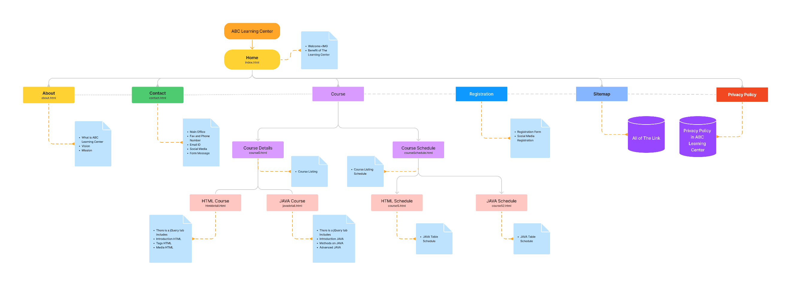

1. Storyboard

Task 3

Task Statement:

1. Develop the HTML Pages required for the website

2. Develop the Lead Generation Form & Administration System pages for Lead Generation

form management.

3. Include the screen capture as part of Project Presentation

Solution:

|  |  |
| --- | --- |
| Lead Generation Form |  |
| Administration System |  |

1. Task 4

Task Statement

1. Propose & use jQuery Components such as menu, popup etc as part of the website.

2. Design the required HTML for jQuery Components.

3. Provide screen capture as part of Project Presentation.

Solution

1. I’m use jQuery in slide dropdown in navbar, jQuery tab in course listing, and course detail, also I’m use jQuery method on registration form, admin page for push, edit, delete, and add data.
2. A. Navbar



B. Tab

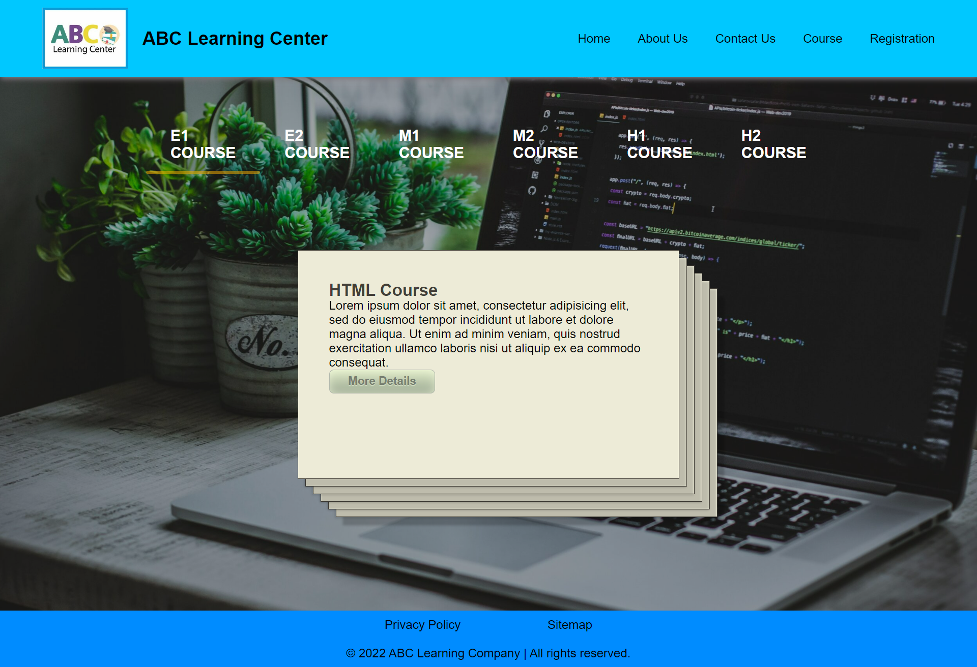

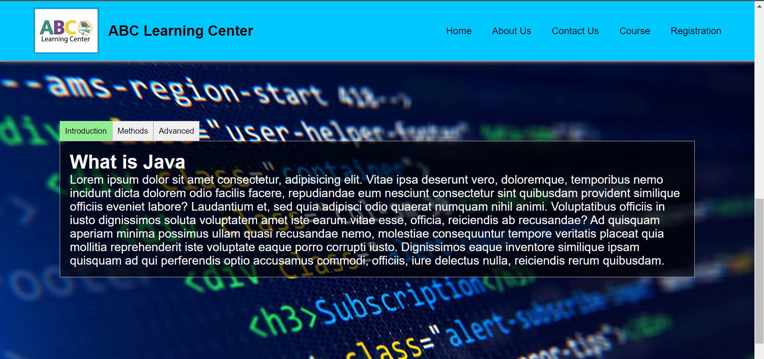

C. JQuery Push data

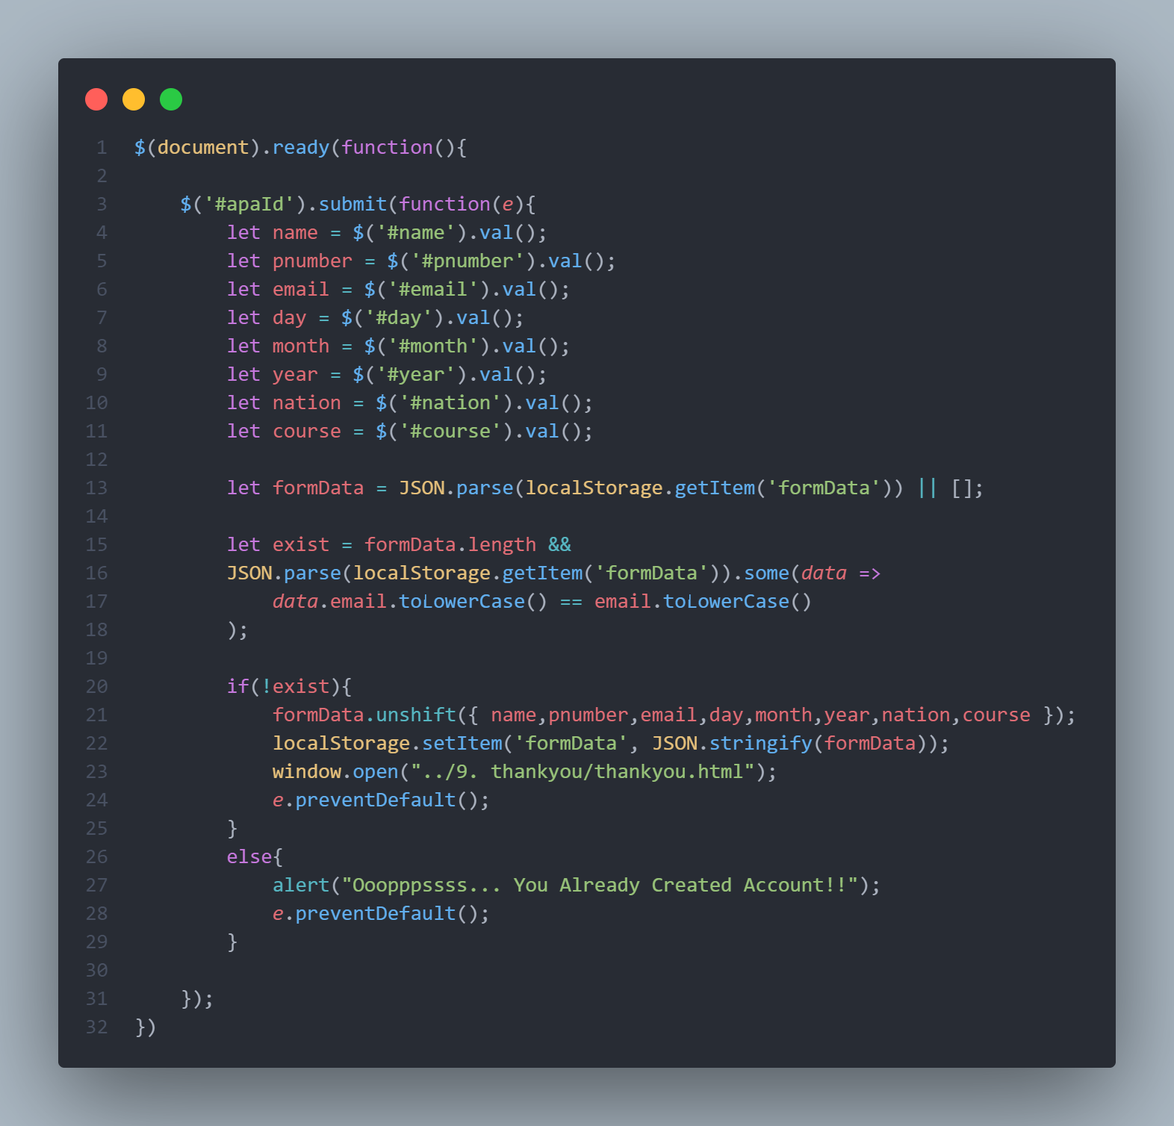

1. Task 5

Task Statement

1. Write a paragraph on the effectiveness of the designed Lead Generation Administration

System.

2. Write briefly on effectiveness of the User interface according to 2 metrics

3. Include it as part of Project Report.

Solution

Before submitting or continuing, the registration form should be able to notify the user of any errors they have committed. The errors should be presented so that it is simple for the user to locate and fix the error. As a result, the data we get from the user will be more accurate.

2 metrics

1. Form validation.

Its is checking for valid email id and contact number

2. Proper description of the error

Errors are displayed in a helpful way. So that it becomes easy for the user to debug and fill proper input.

1. Task 6

Task Statement:

1. Make changes to User Interface based on effectiveness metrics identified in Task 5.

2. Make the changes to HTML, CSS & Javascript.

3. Include the screen capture along with list of modifications made as part of Project

Presentation.

Solution

1. Screenshot of form validation

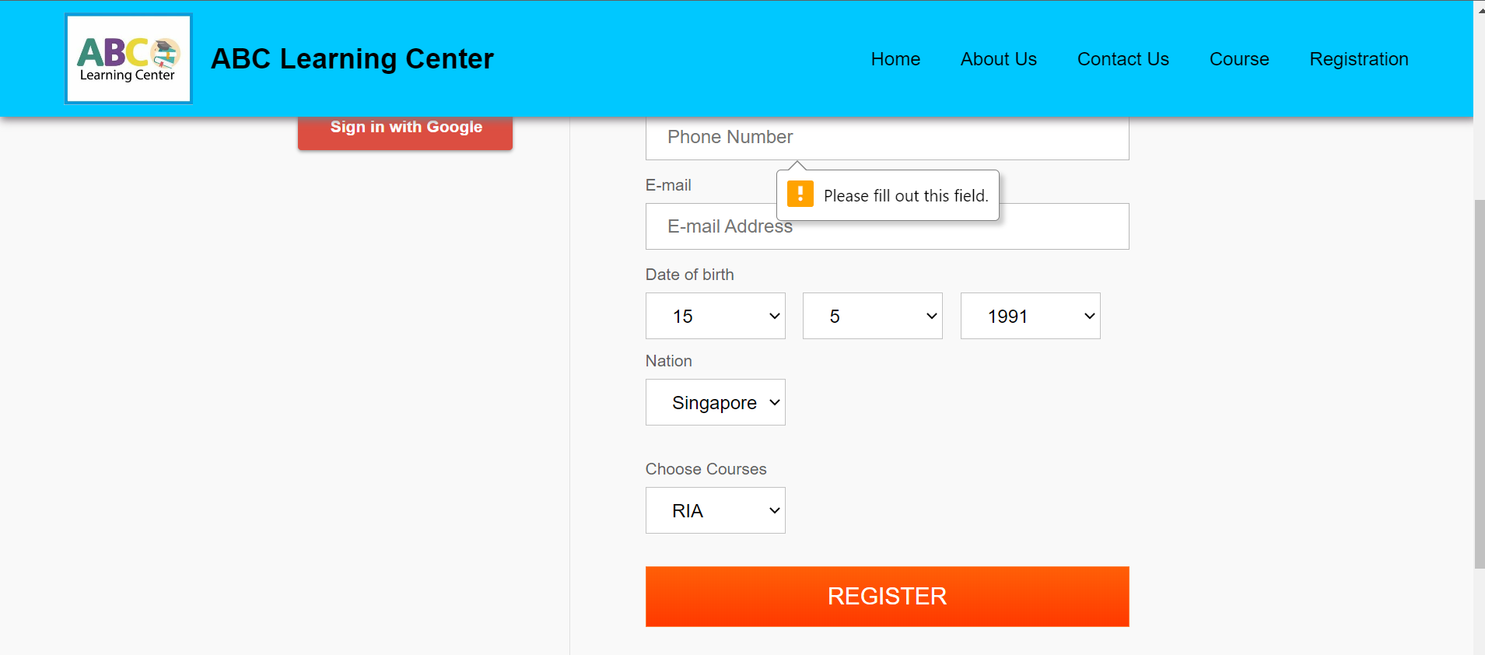

1. Screenshot of the error for incorrect input.

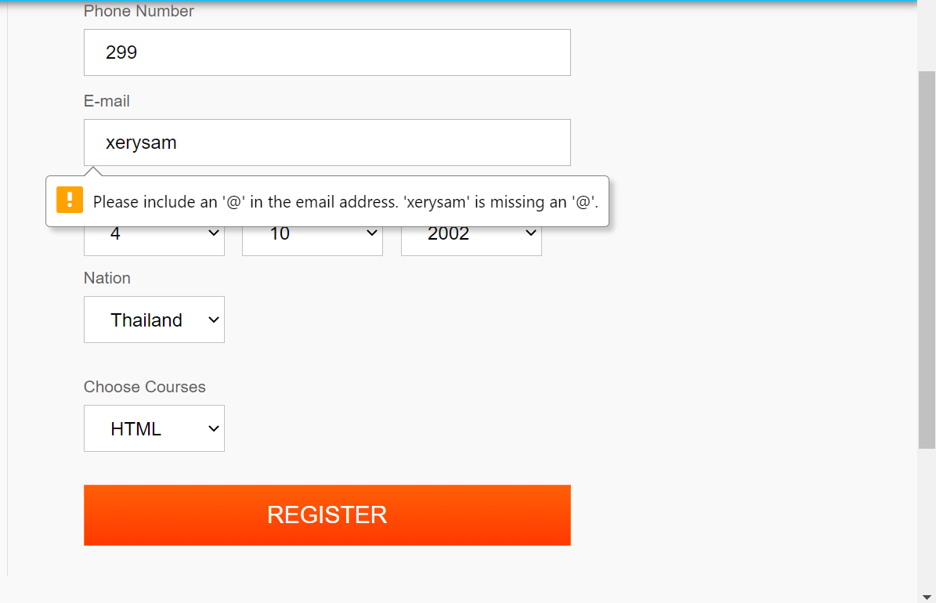

1. Task 7

Task Statement

1. User Guide Lead Generation Form
2. User Guide Associated Administration
3. Include it as part of Project Report

Solution

* First, clients need Windows 7, 8, 8.1, 10, and 11 operating systems, Apache 2.4, or Apache TomCat for hosting their websites.
* Second, put the project document into .htdocs in Apache 2.4.

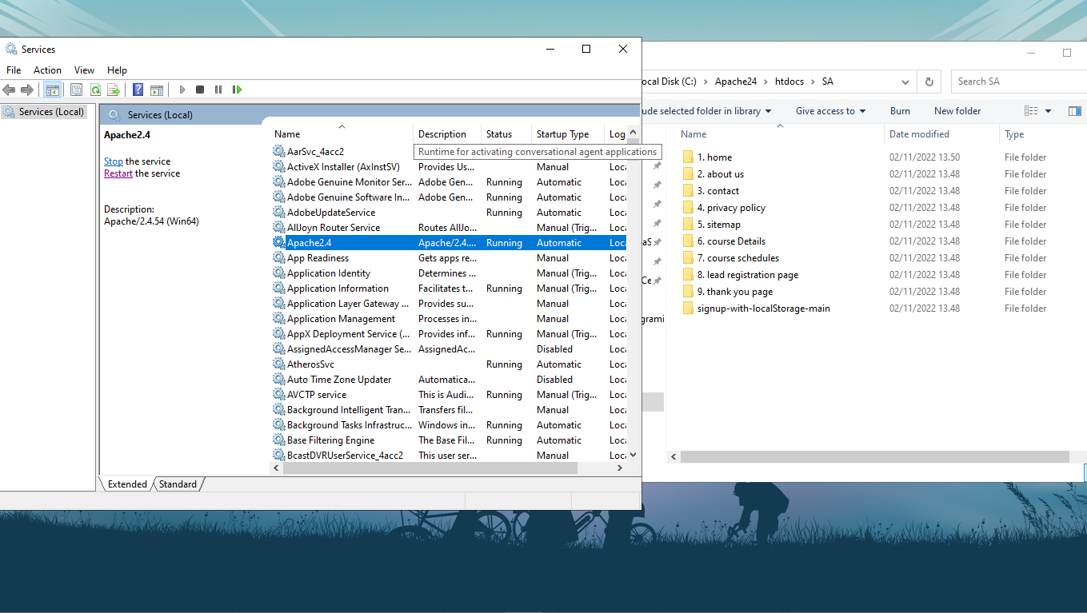

* Third, open the default browser Google Chrome, Microsoft Edge type localhost/theprojectfolder/index.html.

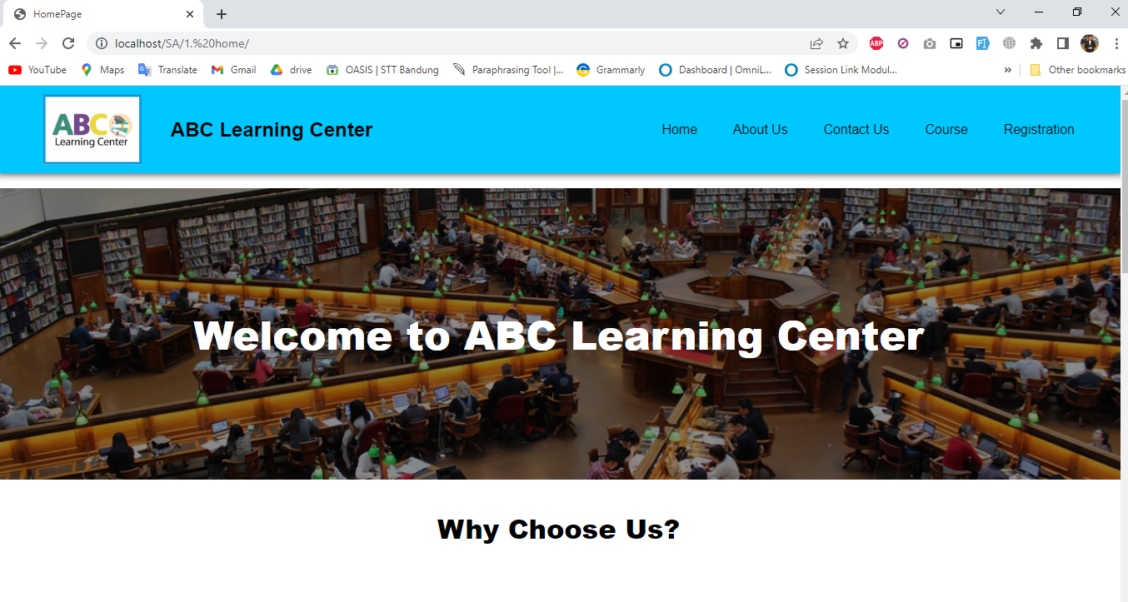

* Next, click the registration menu on the right above the websites.

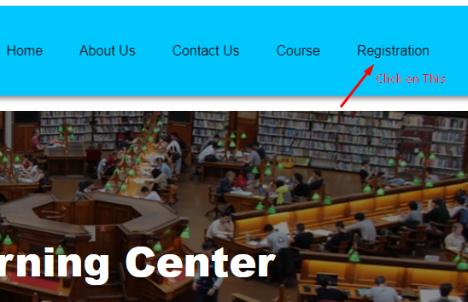

* After the registration form appears, you can fill the form with the correct information.

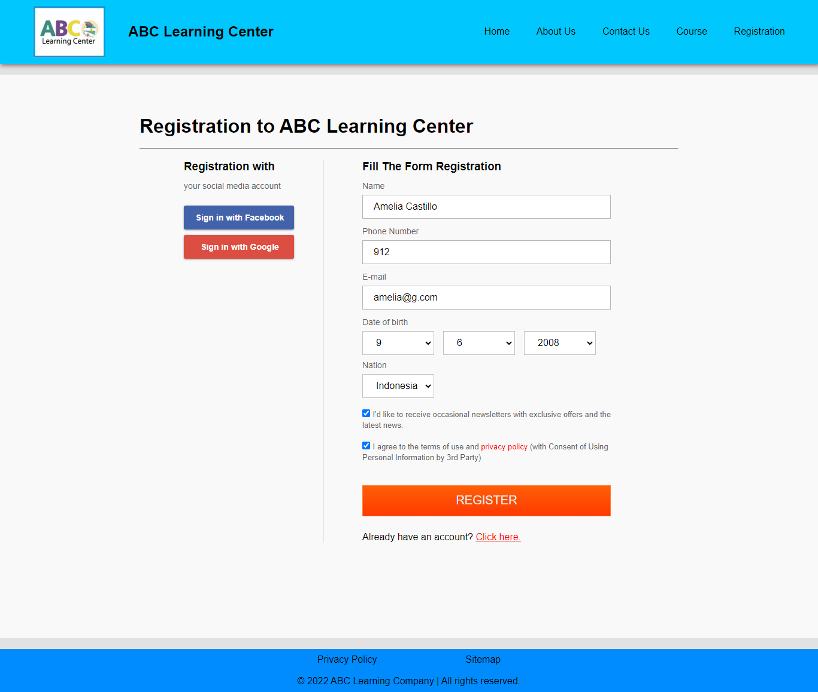

* Then click register, and it will show thank you page.

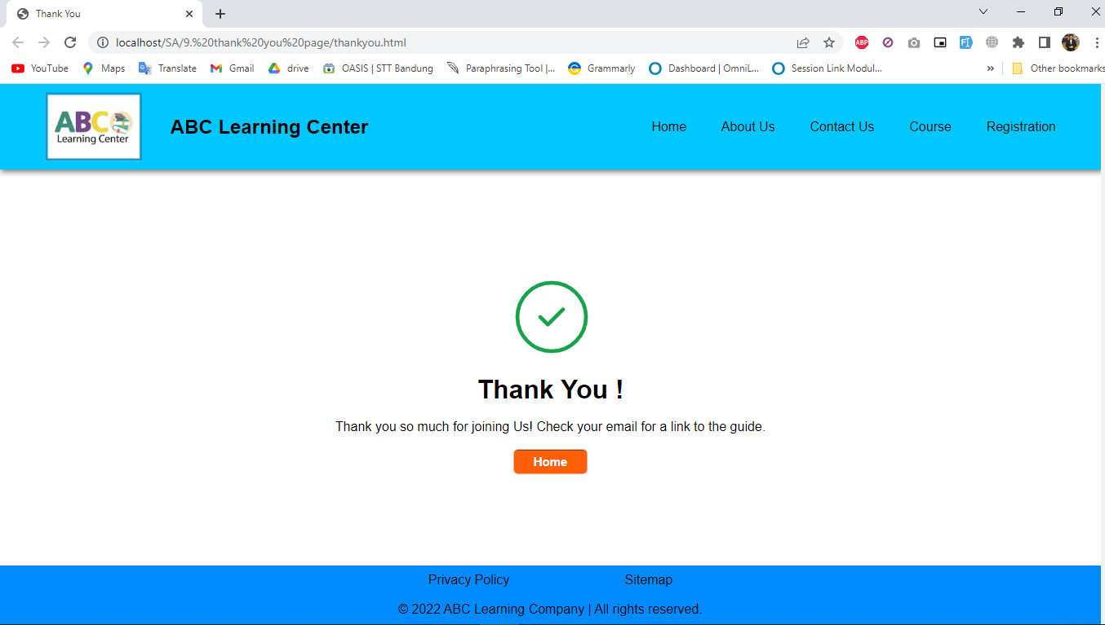

* If you want to open Administration page, just change admin.html so you can see the data

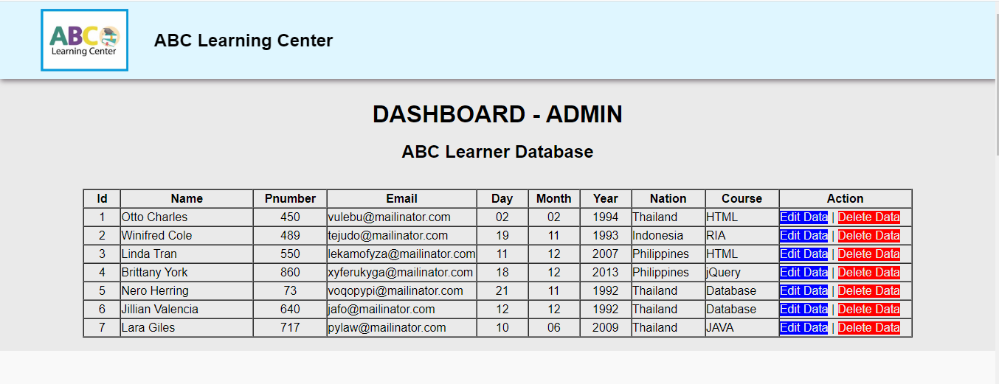

* And you can edit the data with the form

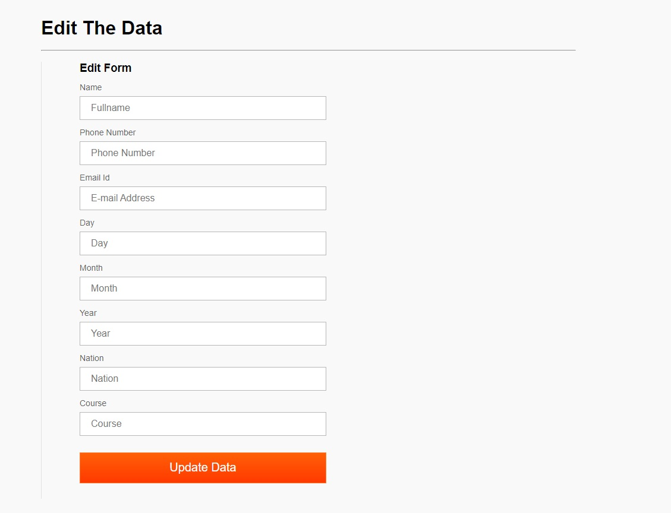

* The last thing you can also add the data from the Administration Page

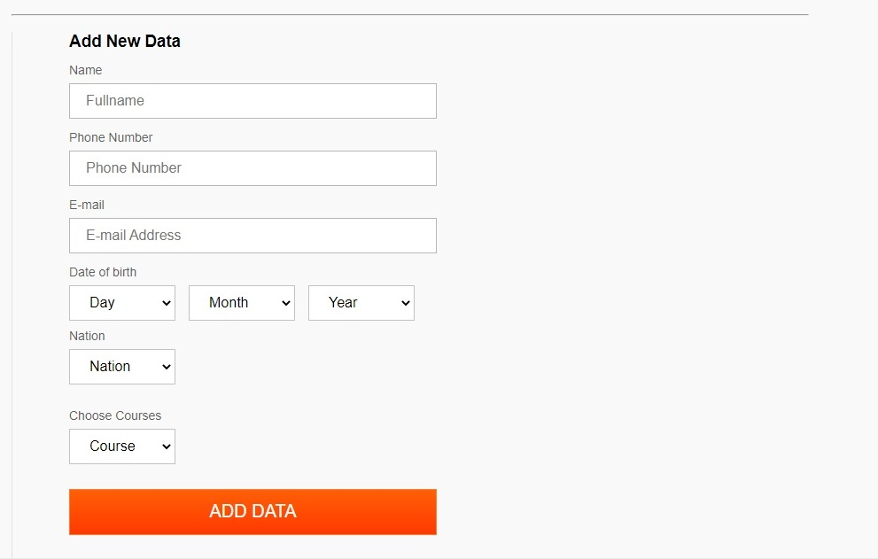

* This is what happen if you add, edit and also delete the data. It will change.

